**Basic Of Hypothesis :**

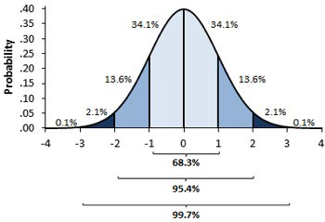

the graph is properly distributed and**mean =0 and variance =1 always**. concept of z-score comes in picture when we use **standardised normal data.**

**Normal Distribution :**

A variable is said to be normally distributed or have a **normal distribution** if **its distribution** has the shape of a **normal curve** — a special bell-shaped **curve**. … The graph of a **normal distribution** is called the **normal curve**, which has all of the following **properties**: 1. The mean, median, and mode are equal.

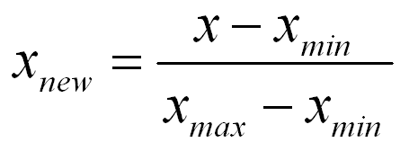

**Standardised Normal Distribution :**

**A standard normal distribution is a normal distribution with mean 0 and standard deviation 1**

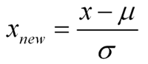

**Level of significance:**

**Refers to the degree of significance in which we accept or reject the null-hypothesis. 100% accuracy is not possible for accepting or rejecting a hypothesis, so we therefore select a level of significance that is usually 5%.**

**This is normally denoted with alpha(maths symbol ) and generally it is 0.05 or 5% , which means your output should be 95% confident to give similar kind of result in each sample.**

**Type I error:** **When we reject the null hypothesis, although that hypothesis was true. Type I error is denoted by alpha. In hypothesis testing, the normal curve that shows the critical region is called the alpha region**

**Type II errors:** **When we accept the null hypothesis but it is false. Type II errors are denoted by beta. In Hypothesis testing, the normal curve that shows the acceptance region is called the beta region.**

**Which are important parameter of hypothesis testing ?**

**Null hypothesis :- In inferential statistics, the null hypothesis is a general statement or default position that there is no relationship between two measured phenomena, or no association among groups.In other words it is a basic assumption or made based on domain or problem knowledge. Example : a company production is = 50 unit/per day etc.**

**Alternative hypothesis :-** **The alternative hypothesis is the hypothesis used in hypothesis testing that is contrary to the null hypothesis. It is usually taken to be that the observations are the result of a real effect (with some amount of chance variation superposed) Example : a company production is !=50 unit/per day etc.**

T-Test :

<https://www.analyticsvidhya.com/blog/2019/05/statistics-t-test-introduction-r-implementation/?utm_source=blog&utm_medium=ab-testing-data-science>

<https://www.analyticsvidhya.com/blog/2020/06/statistics-analytics-hypothesis-testing-z-test-t-test/?utm_source=blog&utm_medium=ab-testing-data-science>

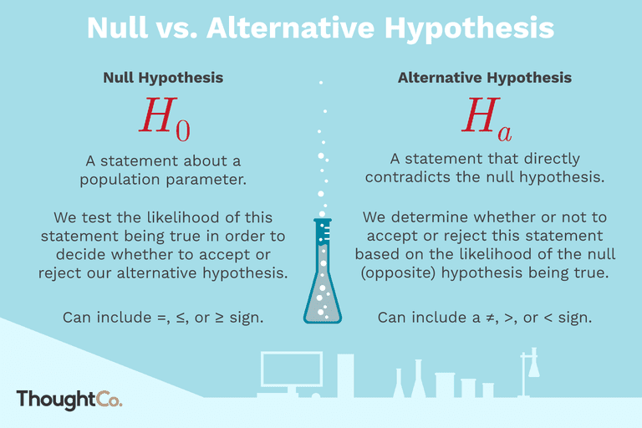

**ANOVA vs. T Test :**

**A Student’s t-test will tell you if there is a significant variation between groups. A t-test compares means, while the ANOVA compares variances between populations.**

**P-value :**

**The p-value is a probability of getting the observed value of the test statistic or a value with even greater evidence against Null hypothesis (H0), if the null hypothesis is actually true. The smaller p-value ,the greater the evidence.**

